

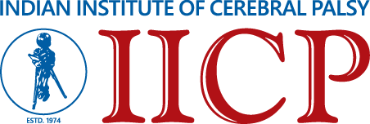

**Announces**

**ADMISSION IN**

**B.Ed. Special Education (Multiple Disabilities)**

**Affiliated by: Jadavpur University**

**Recognised by: Rehabilitation Council of India**

**ADMISSION NOTIFICATION**

Applications are invited for admission in B.Ed. Special Education (Multiple Disabilities) course, at Indian Institute of Cerebral Palsy, recognised by Rehabilitation Council of India and affiliated by Jadavpur University, for the academic year 2024-26.

**ELIGIBILITY (as per RCI rules)**

Candidates with at least 50% marks either in the Bachelor’s Degree and/or in the Master’s degree in Sciences/Social Sciences/Humanities, Bachelors in Engineering or, Technology with specialization in Science and Mathematics with 55% marks or, any other qualification equivalent thereto, are eligible for admission to the programme.

**ADMISSION CRITERIA**

Candidates will be selected on the basis of interview

# The reservation and relaxation for SC/ST/OBC/PWD and other categories shall be as per the rules of the State Government.

**ADMISSION PROCESS**

Application form and Information Brochure will be available from the IICP website [www.iicpindia.org](http://www.iicpindia.org) from 03.12.24. Last date of submission of duly filled-in Application Form at IICP in person or, by Post on or, before 20.01.25. Applicants must deposit a non-refundable Application Fee of Rs 200/- to the following bank account details or cash:

Account Holder: INDIAN INSTITUTE OF CEREBRAL PALSY

Bank Name: ICICI BANK LIMITED

Branch: TARATALA

A/C No.: 128401000055

A/C Type: Savings Account

IFSC Code: ICIC0001286

Course at a glance

Total Seats: 30

Course Fees: contact office

Course Duration: 2 Years, Full

Date of Interview: 21.01.25

Date of 2nd Selection – 22.01.25 *

Classes will be held at the Indian Institute of Cerebral Palsy, Kolkata

* All dates are tentative and subject to change.

*Admission fees will be non-refundable once enrollment is confirmed.

**For details contact Ms. Susrita Pradhan, Deputy Director, IICP**

**Phone: 2401-3488/0240/2348, Mobile number - 9123094377**

(MS SONALI NANDI)

Chief Operations Officer & Director, Technical Services

Indian Institute of Cerebral Palsy (I.I.C.P.)